

ZONTA AM

ZONTA CLUB OF AMHERST
DISTRICT #4
May 2014 Governor: Dr. Lee Fogarty
District 4 Website:www.zontadistrict4.org
Area 4 Director: Mary Yunker
Zonta of Amherst Website: www.AmherstZonta.org

Dear Sisters,

There is a lot of information in this month’s newsletter – about our year-end banquet coming up, the yard sale, saving your unwanted professional clothes to pass along to “Dress for Success”, the potluck dinner and more – please look things over carefully and ask if you have any questions.

I am so glad that we could come together and attend the wake and service and say goodbye to our sister and Past President, Anita. She was so positive, so inspiring and always ready to lend her hands, her thoughts and her spirit to all projects. I know you will keep her, along with her her family and friends, in your thoughts and prayers. There are no words that can express how much we will miss her.

Also, please send your words of care our Zonta sister Dorothy Holmes. Her husband Robert passed away on April 2nd and we all wish we could help at such a time of grief. Memorial contributions in Robert’s name may be made to the Northeast Kidney Foundation, 501 New Karner Rd., Suite 6, Albany, NY 12205.
- Donna

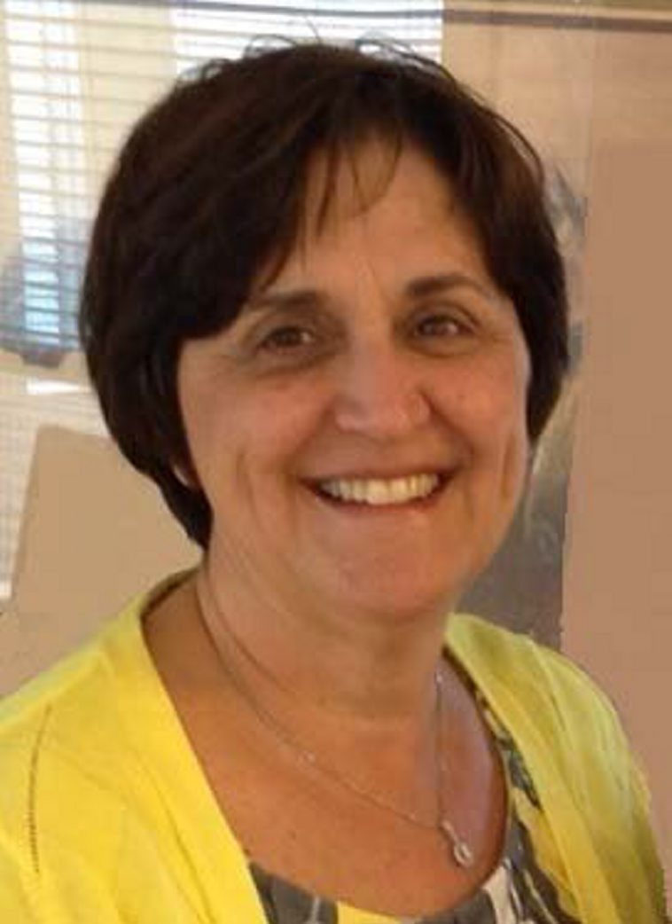
ZONTA INTERNATIONAL
MISSION STATEMENT
Zonta International is a global service organization of executives and professionals working together to advance the status of women through service and advocacy
ZONTA CLUB OF AMHERST
MISSION STATEMENT
Create renewed enthusiasm in each member to enable the Zonta Club of Amherst to take on the cause of women’s health, participate in District and support International endeavors.

Do not stand at my grave and weep
I am not there. I do not sleep.
I am a thousand winds that blow.
I am the diamond glints on snow.
I am the sunlight on ripened grain.
I am the gentle autumn rain.
When you awaken in the morning's hush
I am the swift uplifting rush
Of quiet birds in circled flight.
I am the soft stars that shine at night.
Do not stand at my grave and cry;
I am not there. I did not die.
Author: Mary Elizabeth Frye

Anita M. Sandecki
March 1, 1953 – April 30, 2014



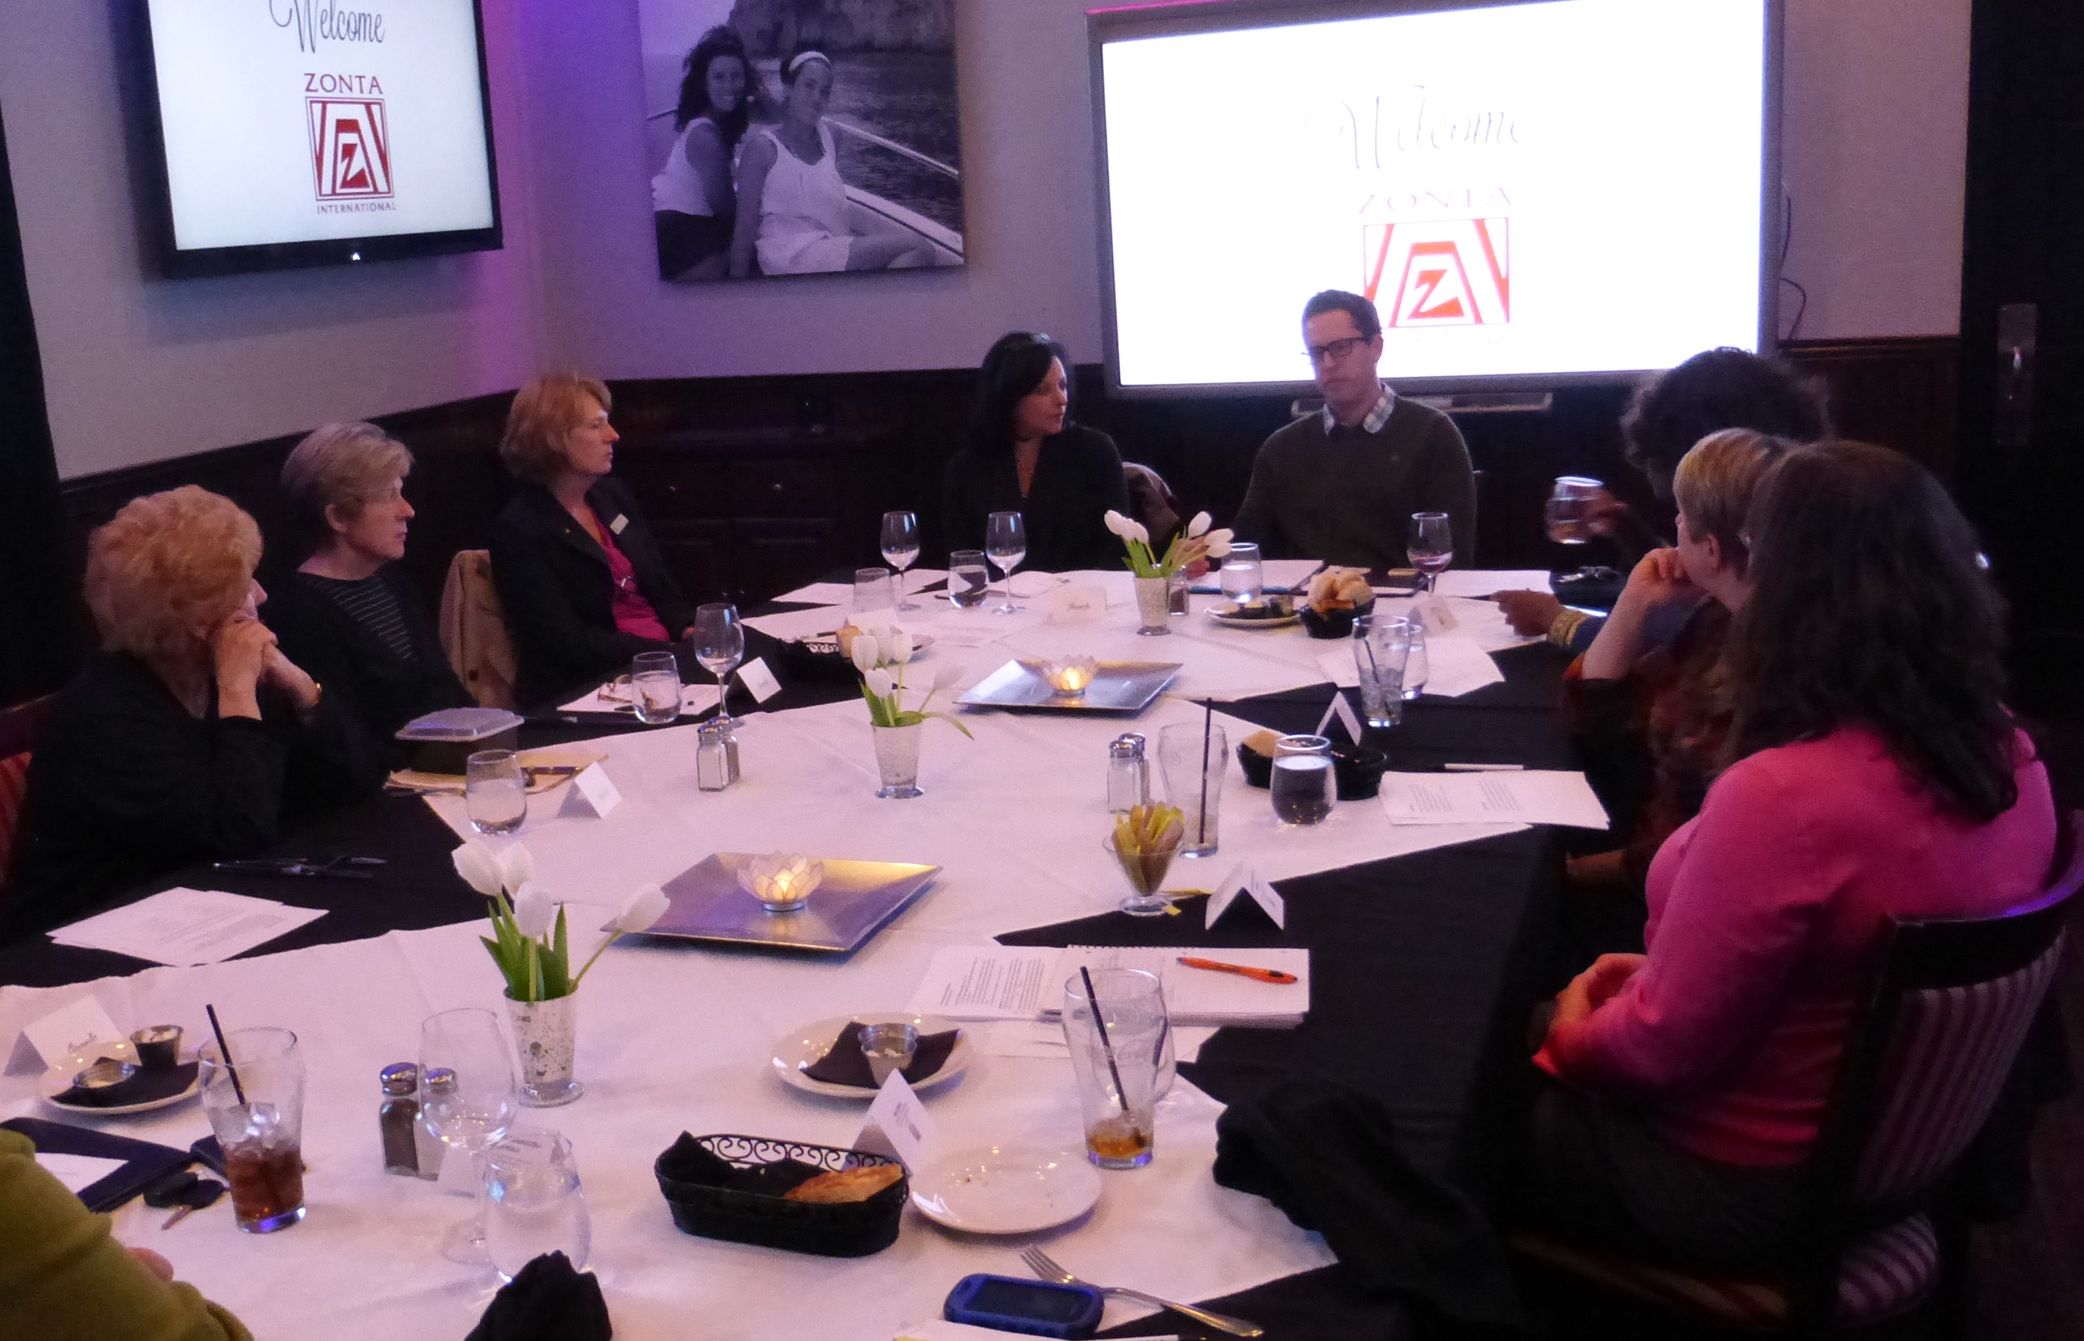

If you would like to make a donation, or send Zonta related correspondence, you can reach the Zonta Club of Amherst NY at:
Zonta of Amherst – President, 66 Mahogany Drive, Williamsville NY 14221

,

Zonta of Amherst May 2014 pg 2
The April dinner meeting is at Giancarlo’s is on Tuesday, May 27th
2014 Important Zonta of Amherst Dates!

May 2014
5/27/14 Installation of Officers; scholarship presentation
Held at Giancarlo’s – 6pm

June 2014
6/10/14 Meeting old/new Board/members potluck at Kay’s house!
6/21/14 Yard Sale fundraiser

President
Donna Cicero

Vice President
Roselle Fairl

Treasurer
Mary-Diana Pouli

Secretary
Robin Erwin

Board of Directors
Shirley Havice
Kathy Reynolds

Happy April
Birthday to:

Connie Smith – May 6

Our April speaker for Earth Day was Brian Smith,
Program & Communications Director at Citizens
Campaign for the Environment

Dinner choices are Eggplant Parmesan, Grilled Steak, or Chicken Tuscano (chicken with a rosemary and butter sauce) with brownie for dessert. Dinner is $35 for this year-end banquet.
YOU ARE WELCOME TO BRING GUESTS! Why not treat a friend to dinner and see if they would like to join our club? Or bring your partner or spouse to share a Tuesday night with you and meet us all?
6:00 Socializing
6:30 Dinner
7:00 Program
No substitutions and $35 due at dinner (exact payment helpful)!

Our May Banquet meeting with include presentation to our 2014 scholarship winner and officer & directors induction by Mary Yunker (Outgoing Area 4 Director), and Mary Jane Wajmer (Incoming Area 4 Director).

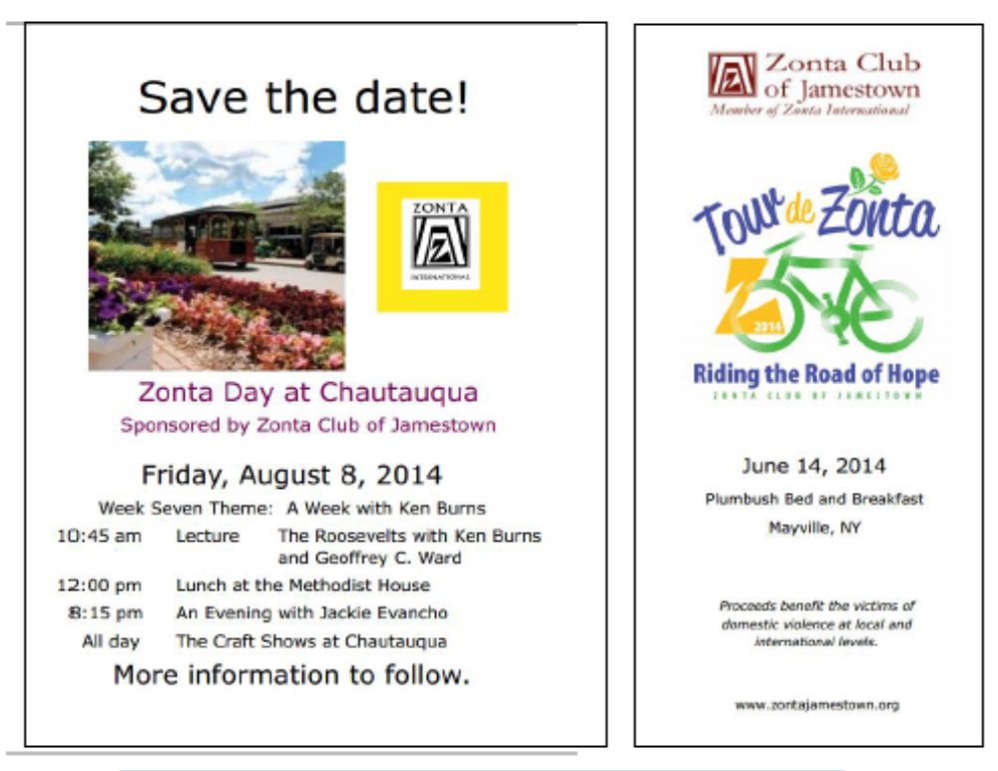

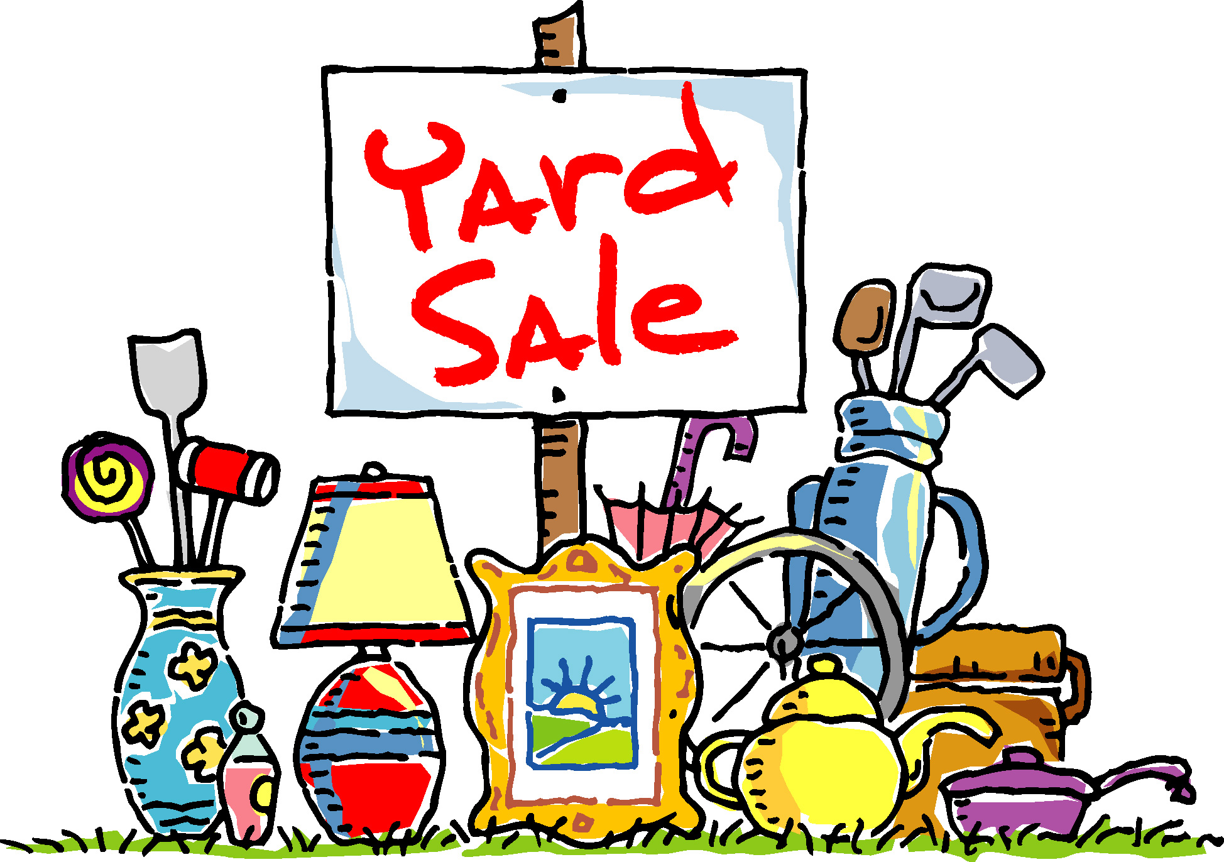

Zonta of Amherst May 2014 pg 3
For Your Consideration:
We are so pleased to be able to offer Pat Turesky to be voted on as our newest Zontian. Pat is a dedicated volunteer in the community, has served on the Town of Amherst Youth Board and as liaison to the Family Room (a large organization of mostly mothers with children under the age of 5). Pat is a committed, dynamic “doer” and will be a great asset to our club. She is being sponsored by Sherry Baiocco. Please join us in welcoming her at this month’s meeting and voting on her application.
Our Yard Sale Fundraiser with be Saturday, June 21, at 74 Morning Side, 14221.
You may drop off your pre-priced items on Friday, June 20th from 6:30 to 8:30pm.
NO CLOTHING PLEASE. If you wish to keep any of your unsold materials, you
MUST be at the yard sale by 12:30pm – otherwise, they will be donated to
charity.
WE NEED TO BORROW YOUR TABLES! Label yours and bring them with
Your items to sell. If the weather is good, this is an easy fundraiser!

While finding things to sell, please put aside any professional woman’s clothing as we will have a speaker in the fall from “Dress for Success”. They will take your usual professional clothing for woman in need. Please put those somewhere safe until we meet in the fall.
CONVENTION UPDATE:
Bonnie Botsford of the Buffalo Club will be carrying our vote to the Convention in Orlando.
Please go to http://www.zonta.org/MemberResources/Convention/BylawsQA.aspx
so you can see the changes to Zonta International’s by-laws and be an informed club member!

Young Women in Public Affairs (YWPA) Award - Zonta International District 4

The District 4 Awards Committee is very pleased to announce that Christina Weber, submitted by the Zonta Club of St. Catharines, Ontario has been selected as the District 4 YWPA winner. Christina will receive $1,000 from Zonta International as the District 4 YWPA award. The District 4 Awards Committee received applications from 13 clubs out of the 39 clubs in the district (2013 16 clubs). Total applications received by the 13 clubs was 40 (2013 68 applications). The candidates were all exceptional young women creating a very difficult job for the judges.

Christina plans to attend university for a Health Sciences degree with a specialization in global health at McMaster University or to pursue a Bachelor of Science degree with a minor in International Development at Queen’s University. Christina’s current average is 99.25%. She states that she “will always continue to volunteer both locally and internationally, and I hope to experience as much of the world as I possibly can”.

Throughout high school she has become a passionate leader of change both locally and globally, as a member of her school's student council along with many clubs and sports. In grade 10 Christina was a leader of Project (Out)Standing, an anti-bullying campaign that worked to increase the self-esteem of local elementary school students so the bully's opinion was no longer important. In grade 11 she co-chaired the Relay for Life event which raised $81000 for cancer research, and she spearheaded an organ donation awareness campaign! For the past two years Christina created and organized various Me to We campaigns (such as We Scare Hunger) as well as campaigns for a Make the Homeless Smile Initiative, a Movember fundraiser for Wellsprings Niagara and a 24-hour famine to raise over $10000 for an international charity. “Through all of these activities I've gained confidence and perspective. They have enabled me to grow not only as a leader, but also as a person.”

In 2013 Christina was selected as an ambassador for the District School Board of Niagara International for a build with Habitat for Humanity in Vietnam. This March Break she travelled to Antigua Guatemala with International Volunteer HQ to volunteer in an orphanage. She describes her 2013 trip as “the most incredible experience of my life. I learned to understand not only their culture, but also the power of communicating without words (as none of the children spoke English and none of us knew how to speak Vietnamese)!” Christina’s teacher-reference writes: “I have never had a student demonstrate such commitment and initiative when taking on volunteer leadership tasks. It is obvious that Christina loves her community and wants to make it a better place.” Christina’s application is filled with amazing achievements for such a young woman in the areas of public policy, government and volunteer organizations. The District Awards Committee felt Christina truly exemplified these goals of Zonta!

Zonta International will announce the ten recipients of the International YWPA award of $4,000 in the first week of July 2014.

I wish to extend a sincere thank you to the District 4 Awards Committee members for their support to the YWPA program. These Zontians are: Judith Yorke, Zonta Club of Olean, NY Marnie Piggot, Zonta Club of Oakville, Ontario, Rujirutana Mandhachitara, Zonta Club of Pittsburgh, PA, Gabriella Sciolino, Zonta Club of Cheektowaga-Lancaster, NY, District 4 Awards Co-Chair

Thank you for giving me the opportunity to act as Co-Chair of the Awards Committee. It continues to be well worth the effort for me!

Karin Eckart
Zonta Club of Hamilton 1, Ontario, District 4 Awards Co-Chair



Zonta of Amherst May 2014 pg 4

